National Conference – Northumbria University and Royal British Legion

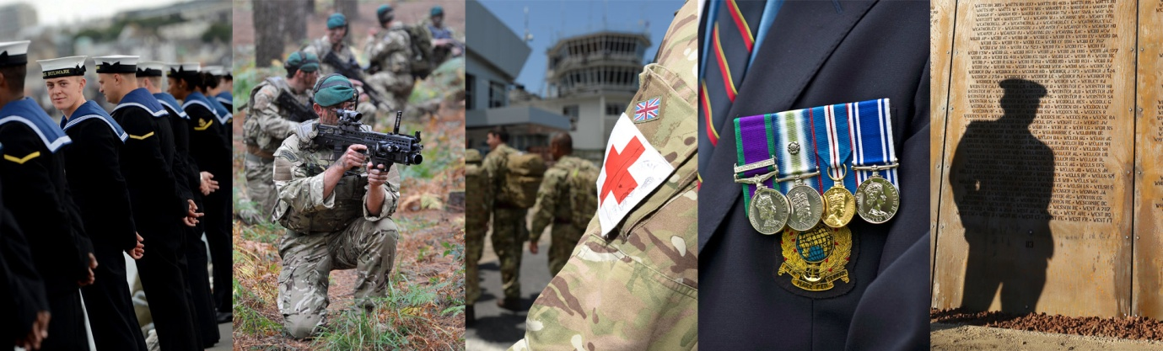

SHAPING THE FUTURE

Veterans Substance Misuse: Breaking Down Barriers to Integration of Health and Social Care

On behalf of Northumbria University and the Veteran and Military Families Research Hub, we are pleased to invite you to attend a one-day national conference to be held in Newcastle on:

16 November 2017
at Newcastle United Football Club (Heroes Suite)
Delegate Fee £25 (All Profits Donated to Royal British Legion Poppy Appeal)

The conference will highlight research findings and draw together experts in the field to speak on the day. The conference is supported by Royal British Legion and NHS England (Armed Forces).

Places are limited but we will do our best to accommodate delegates on a ‘first come, first serve’ basis.

With Thanks, Dr Matt Kiernan and Dr Mick Hill

Co-Founder of The Northern Hub for Veteran and Military Families Research  Dr Matt Kiernan PhD, RN(MH), RGN  Lieutenant Commander RN(Retd)  Post Graduate Research Lead (Nursing, Midwifery and Healthcare)  Co-Founder The Northern Hub for Veteran and Military Families Research  Northumbria University  Coach Lane Campus East  Benton, Newcastle upon Tyne  NE7 7XA  Email: matt.kiernan@northumbria.ac.uk  www.northumbria.ac.uk/militaryveterans | Co-Founder of The Northern Hub for Veteran and Military Families Research  Dr Mick Hill  Postgraduate Research Director  Faulty of Life Sciences  Northumberland University  Coach Lane Campus East  Benton  Newcastle upon Tyne  NE7 7XA  Email: michael.hill@northumbria.ac.uk  www.northumbria.ac.uk/militaryveterans



SHAPING THE FUTURE
Veterans Substance Misuse: Integration of Health and Social Care

16 November 2017
Newcastle United Football Club

09.00 to 09.30 | Registration and Refreshments
09.30 to 09.50 | Opening the Conference | Marcus Hawthorn – Royal British Legion, Area Manager Northern  Andy Bacon – NHS England – Lead (Asst Head) Armed Forces Central Team
09.50 to 10.15 | Setting the Scene | Veterans Personal Stories
10.15 to 11.00 | Research Design and Findings | The Northern Hub for Veterans and Military Families Research, Northumbria University
11.00 – 11.30 | Refreshment Break
11.30 to 12.00 | The Power of Sport. Professional Sports Clubs and Military Culture  Colonel (Retd) Alan Finnegan, Professor of Nursing and Military Mental Health, Chester University
12.00 to 12.30 | Recover from Addiction: The Tom Harrison House Military Specific Model: Jacqui Johnston-Lynch, Tom Harrison House
12.30 to 13.45 | Lunch and Networking
13.45 to 14.15 | Understanding Social Isolation for the Armed Forces Community  Dr Emma Murray and Ester Ragonese, Liverpool John Moores University: Armed Forces Communities and Social Isolation: A Practitioners Perspective. Liverpool John Moores University in collaboration with the Royal British Legion
14.15 to 14.45 | Psychotherapy, Veterans and Substance Misuse  Nicola Salsbury, Highly Specialist Psychotherapist, Military Veterans Service, Bury
14.45 to 15.15 | Presentations of Alcohol Misuse Disorders in Veterans and Spouses: Implications for Clinical Interventions  Kevin Molloy, Service Lead for Substance Misuse Case Management, Combat Stress
15.15 to 15.45 | Refreshment Break
15.45 to 16.15 | ‘Hub & Spoke’ Model Evaluation: Sunderland Local Authority (Public Health)
16.15 – 16.30 | Closing Remarks – Marie-Louise Sharp and Marcus Hawthorne, Research and Healthcare Policy Manager, Royal British Legion

SHAPING THE FUTURE CONFERENCE REGISTRATION
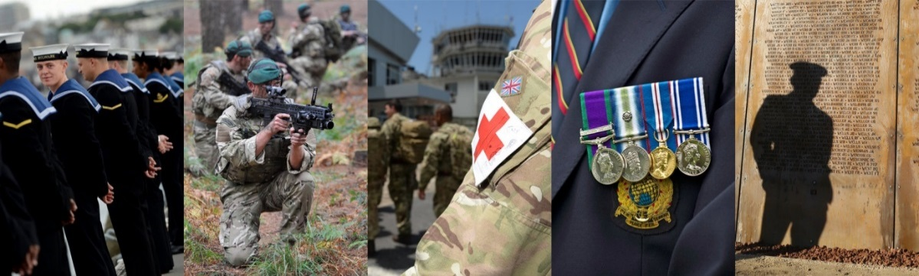
Veterans Substance Misuse: Integration of Health and Social Care

The conference will be held at Newcastle United Football Club (Heroes Suite), Barrack Road, Newcastle upon Tyne, NE1 4ST
on Thursday, 16 November 2017
If you would like to attend, please complete the registration below:
Your Details
Title: |  |  |  |  | First Name: |  |  | Last Name:
Organisation:
Job Title:
Email: |  |  |  |  |  |  | Telephone Number:
The day will include tea/coffee breaks and lunch. Please specify any dietary requirements:
Delegate Fee £25 (All Profits Donated to Royal British Legion Poppy Appeal)
Online payment: https://www.northumbria.ac.uk/onlinepayments/FHLSCONF13/?view=page3
On receipt of payment, your place will be reserved.

